From: <https://medium.com/lessons-from-history/the-survivor-641fd2d283cd>

The Survivor

Thousands Traveled Together, He Was The Only One To Finish The Journey

[Elad Simchayoff](https://medium.com/@eladsi?source=post_page-----641fd2d283cd----------------------)

Follow

[Aug 18](https://medium.com/lessons-from-history/the-survivor-641fd2d283cd?source=post_page-----641fd2d283cd----------------------) , 2020 · 4 min read

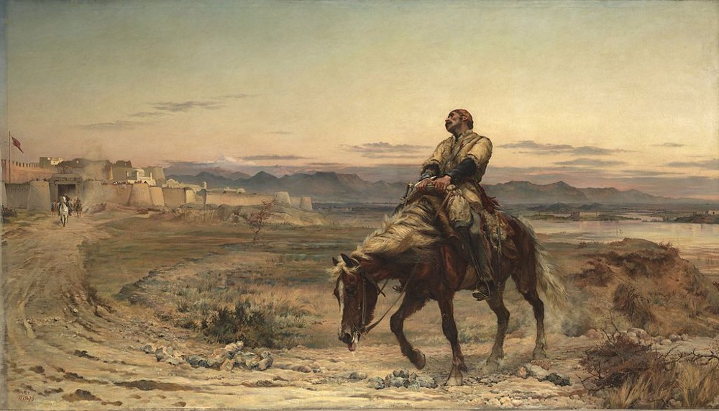

Dr. William Brydon as painted by Elizabeth Butler in ‘Remnants of an Army’

**The First Anglo-Afghan War**

The 1839 invasion of the British army to Afghanistan came at a time of great tension in Europe. The British were concerned that the ruler of Afghanistan, Dost Mohammad, was siding with the Russians and so decided to replace him.

The British invaded Afghanistan from India, using a 21,000-strong British/Indian army, and some 38,000 camp followers (craftsmen and family members). In battle after battle, the British army gained victories, and in August 1839, the capital Kabul was conquered. The British sent Dost Mohammad, the current ruler to exile in India, and reinstated the previous ruler, exiled Shah Shuja, to take charge of the country once again.

Shah Shuja’s rule seemed stable. And so, due to high costs, it was decided that most of the British army would leave Afghanistan, leaving being 8,000 men. The British troops felt comfortable in Kabul, setting up horse races, playing cricket, and bringing over their families from the UK. However, outside of Kabul, a rebel movement was starting to form.

Various local tribes and chiefs were rallying behind Akbar Khan, the son of the exiled leader Dost Mohammad. The rebel movement grew stronger, and yet the British did not take the threat seriously. Things changed with the killing of a high ranking British officer. An angry mob stormed the house of Sir Alexander Burns after he was accused of sexually using local women. He stood in front of the crowd and denied. It ended with him, and his family, all cut down to pieces.

The British commander-in-chief, William Elphinstone, decided not to act in retribution. This made the rebels grow confident. A few weeks later, a negotiation meeting was arranged between a high-ranking British officer and the rebel leader. When the British representatives dismounted their horses to meet with Akbar Khan, the rebels shot them dead.

General Elphinstone was in despair. In a highly controversial act, he decided to reach an agreement with the rebels. The British would give up most of their guns and ammunition in return for a guarantee to allow them safe-passage from Kabul to Jalalabad.

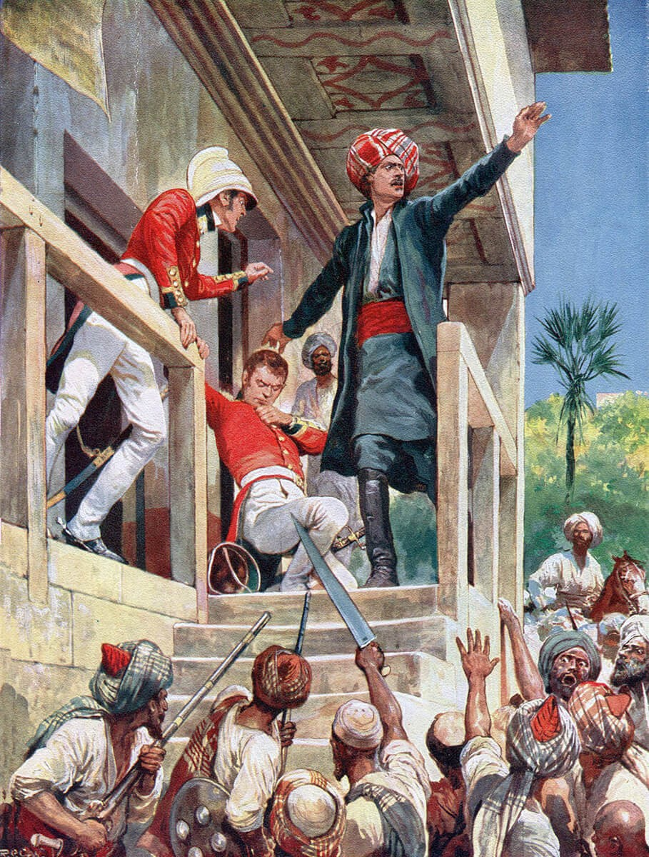

The murder of Sir Alexander Burnes painted by Richard Caton Woodville. Source: [British Battles](https://www.britishbattles.com/first-afghan-war/battle-of-kabul-and-the-retreat-to-gandamak/)

**The Retreat**

On the early morning, 6 January 1842, the British army in Kabul, now holding 4,500 soldiers and 12,000 camp followers, started its move out of the city. Jalalabad was 90 miles (140 km) away.

The rebels did not hold their side of the agreement and attacked the convoy hours after departing. The now well-equipped rebel force managed to ambush the convoy and cause massive damage while shooting from above. The rebels knew the terrain and situated themselves in the high hills, while the large group, with many unarmed women and children, was slowly traveling in the valleys below.

The rebels attacked day and night, causing major losses to the convoy. The temperatures dropped, and many of those who managed to survive the shootings eventually succumb to frostbites and the freezing snow.

Six days later, when the group reached the village of Gangamak, 35 miles (56 km) of Jalalabad, there were only 65 British soldiers left. The final battle took place on the morning of 13 January, and at its end, a few British soldiers were taken captive, the rest were killed.

**The Survivor**

Dr. William Brydon was an assistant surgeon in the British army stationed in Afghanistan. Mounted on his horse, he had made most of the way with the convey until getting separated from the main group alongside 12 other officers.

His companions were targeted and killed, some of them managed to reach a point 15 miles (24 km) out of Jalalabad. Brydon was lucky. Along the way, he encountered men with large stones and managed to escape.

Later, he was shot at, but the bullet only hit and broke his sword. His horse was shot but managed to continue riding. He then encountered five Afghan rebels armed with swords. One struck Brydon’s head.

Brydon survived because he stuffed his hat with a magazine to keep warm. The magazine took most of the hit. Brydon reached for his holster, the Afghans thought he was carrying a gun and fled. He was unarmed.

At the British garrison’s gates in Jalalabad stood an officer looking-out for the convoy coming from Kabul. He saw a dead-like man, riding a dead-like horse. Both were bleeding, badly wounded, exhausted, hungry, and cold. “

Where is the army?”, the officer asked Brydon.

“I am the army”, answered the sole survivor.

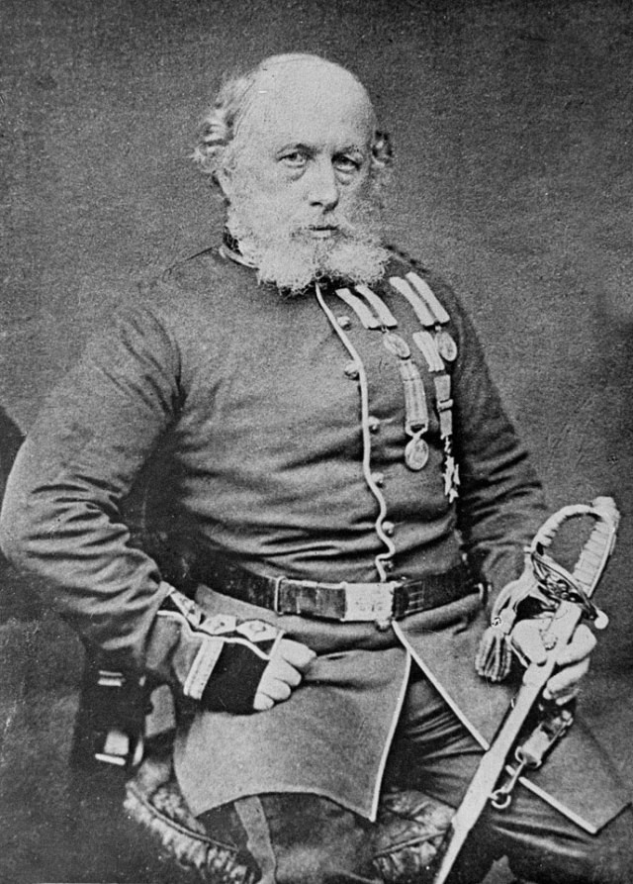

Surgeon-Major William Brydon, 1864. Photo: [National Army Museum](https://collection.nam.ac.uk/detail.php?acc=1961-12-297-1)

**Disaster in Afghanistan**

Brydon was treated and healed. His horse perished soon after arriving at Jalalabad.

Following the massacre, the British sent a large force to retaliate. Akbar Khan was defeated. It was then discovered that among those who were taken captive by the rebels, 115 members of the convoy survived.

There was one member of the British camp, a Greek merchant, who succeeded in completing the journey to Jalalabad as well. He arrived two days after Brydon but died the following day.

Brydon was the only member of those 16,500 men, women, and children to complete the journey and survive. Dr. Brydon continued serving in the British army and fought in the Second Anglo-Burmese War in 1852.

He was badly wounded, but again, was able to fully recover. He died, at his home in the UK, on 20 March 1873.

**[Lessons from History](https://medium.com/lessons-from-history?source=post_sidebar--------------------------post_sidebar-)**

Lessons from History is a platform for writers who share…

Follow

193

* [History](https://medium.com/lessons-from-history/tagged/history)
* [War](https://medium.com/lessons-from-history/tagged/war)
* [Inspiration](https://medium.com/lessons-from-history/tagged/inspiration)
* [Survival](https://medium.com/lessons-from-history/tagged/survival)
* [Afghanistan](https://medium.com/lessons-from-history/tagged/afghanistan)

193 claps

[[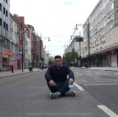](https://medium.com/@eladsi?source=follow_footer--------------------------follow_footer-)](https://medium.com/@eladsi?source=follow_footer--------------------------follow_footer-)

WRITTEN BY

[**Elad Simchayoff**](https://medium.com/@eladsi?source=follow_footer--------------------------follow_footer-)

Follow

I love writing about what I love. Journalist. Always curious. Israeli born, London based. Father, Husband, and a dog person. Travel too much, sleep too little.